AWS Practice Day -3
Create a s3 bucket
1.In search bar search s3
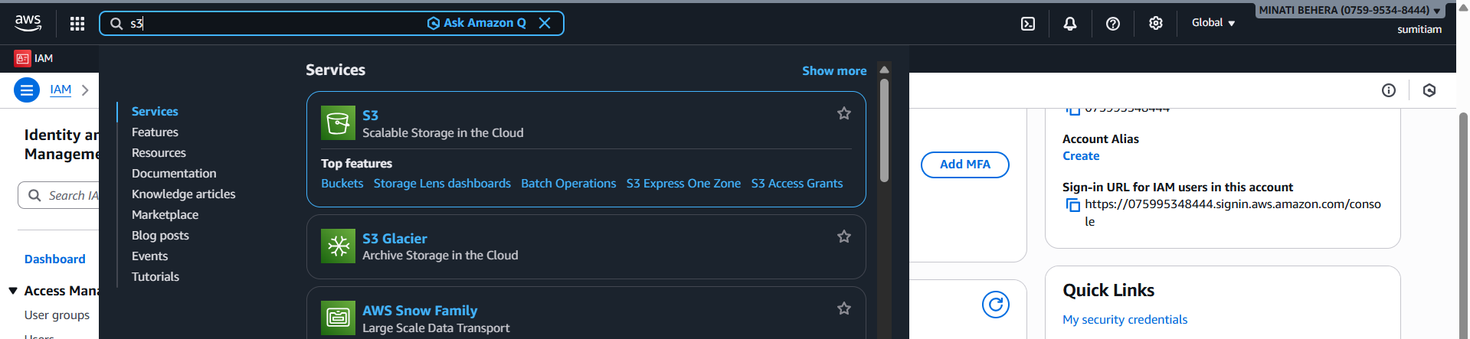
2.Go to general purpose bucket
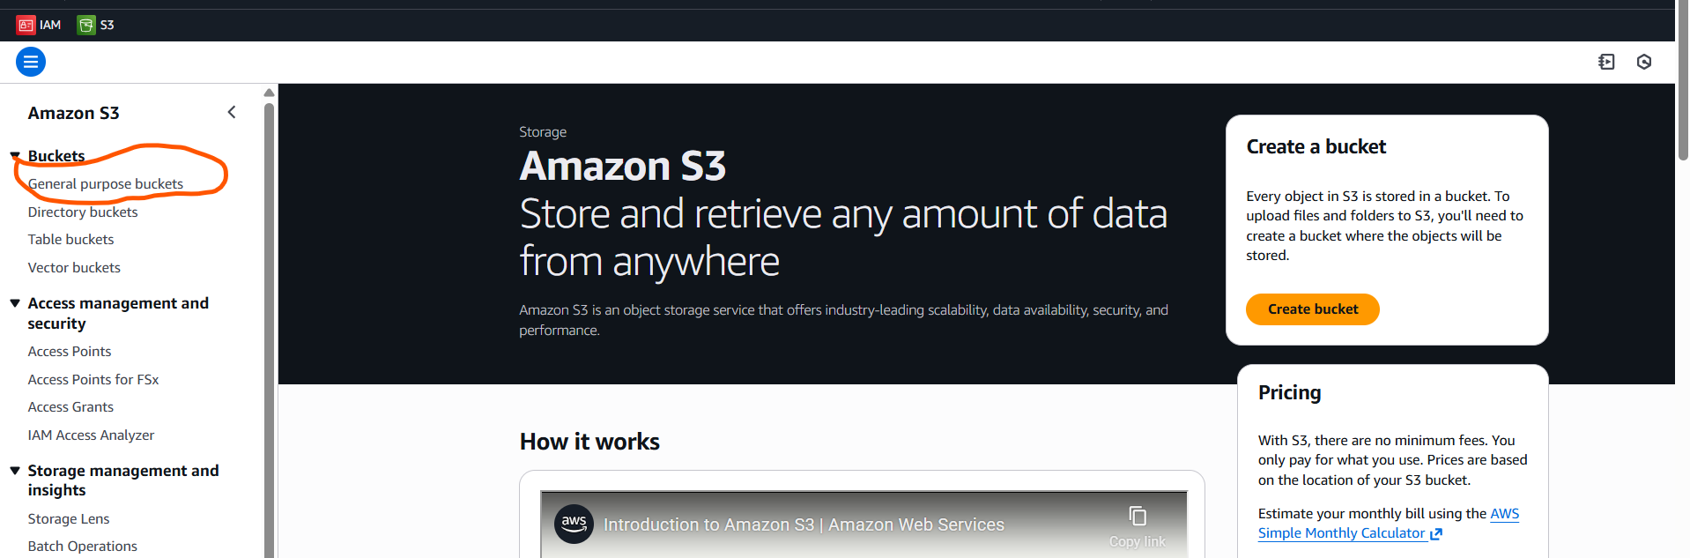
3.click on create bucket
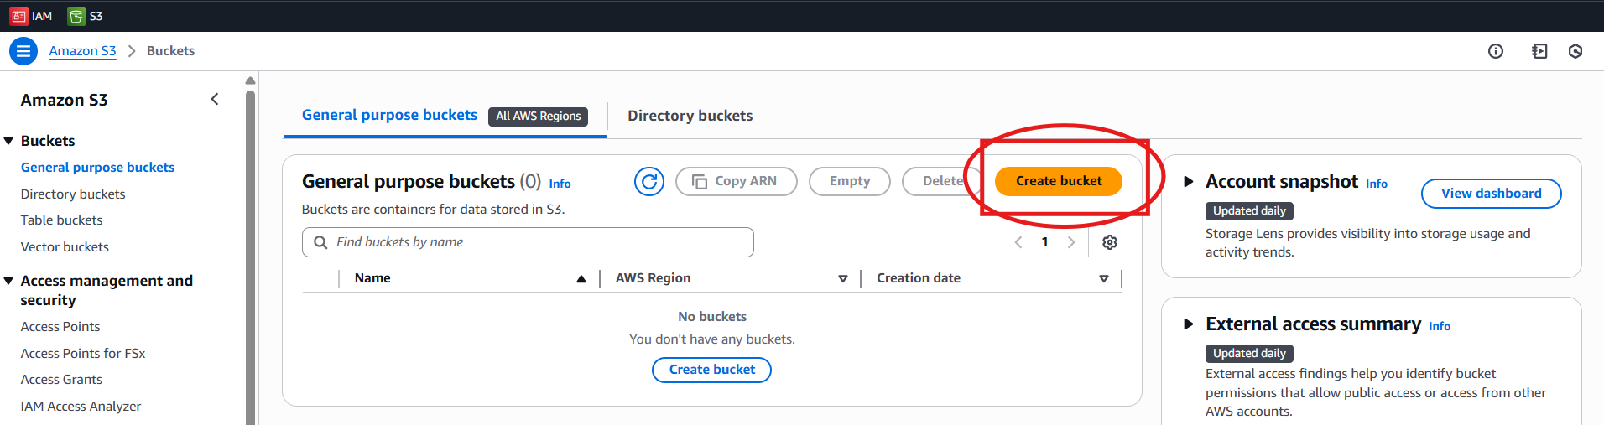

4.Enter Bucket name & scrool down
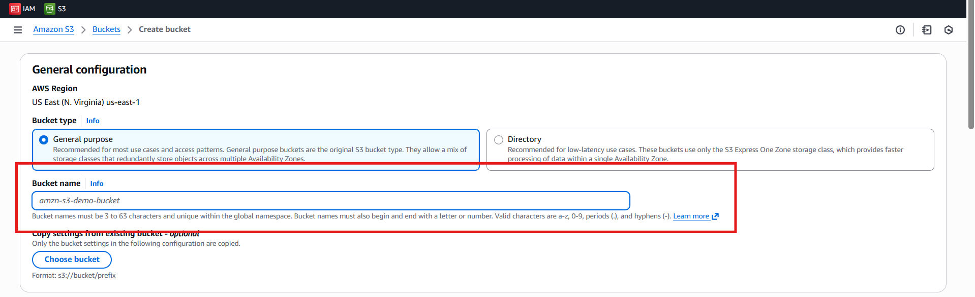
5.do ACLs enable & object ownership chick Bucket owner perferred
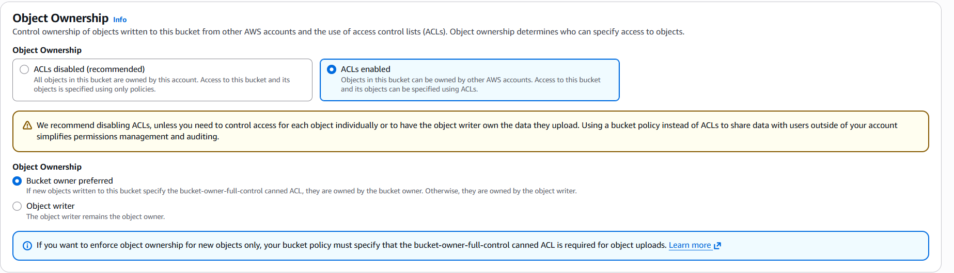
6.un check block all public access & check on I aknowldge
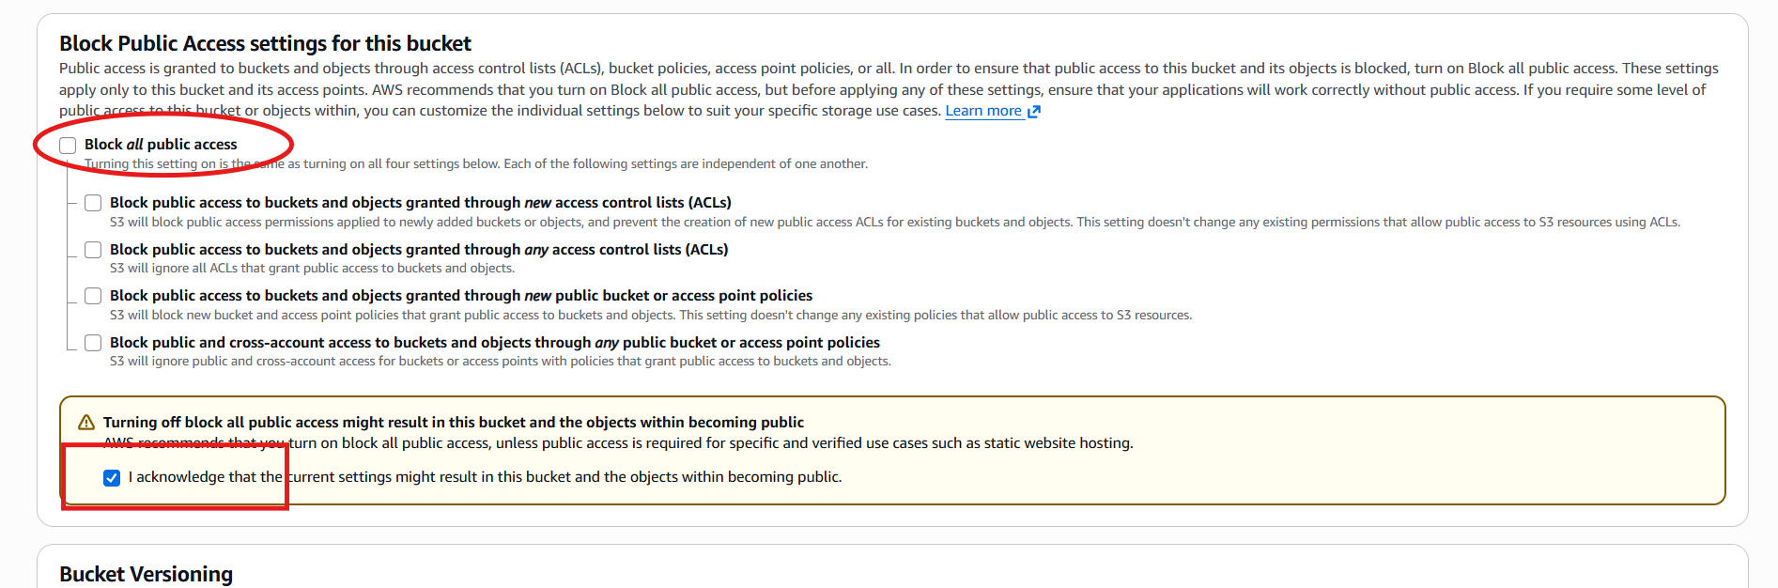
7.Do object lock enable & check acknowledge click tick
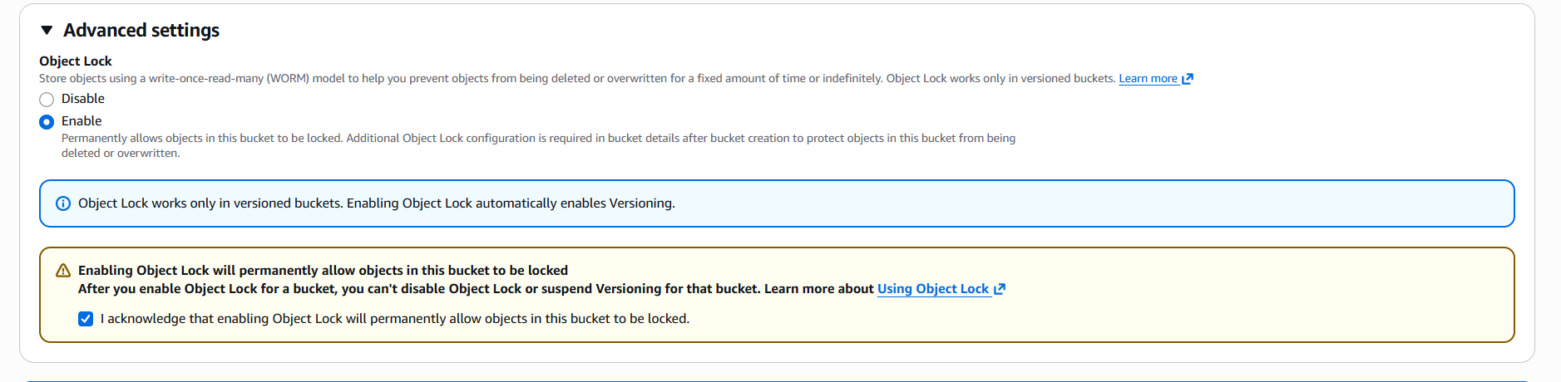

8.Bucket Created click on bucket
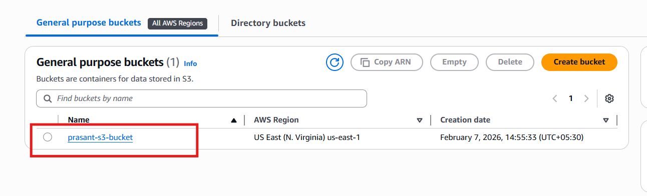
9.Do file upload
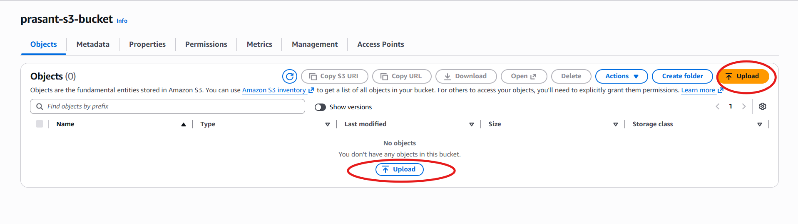
10.click on add files
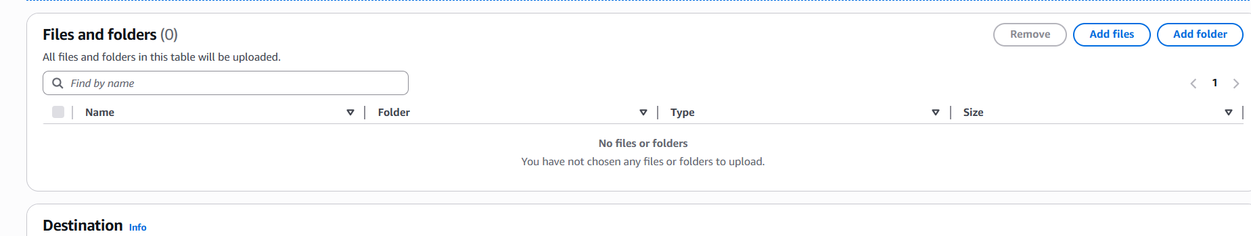
11.check mark on files
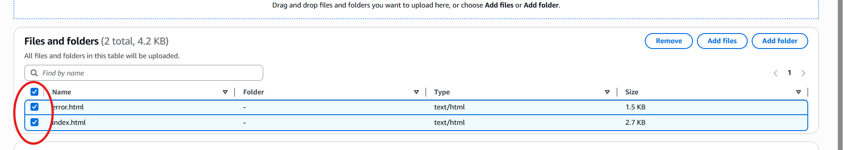
12. Do upload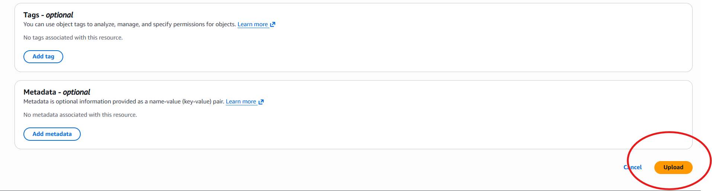
13.Click upload
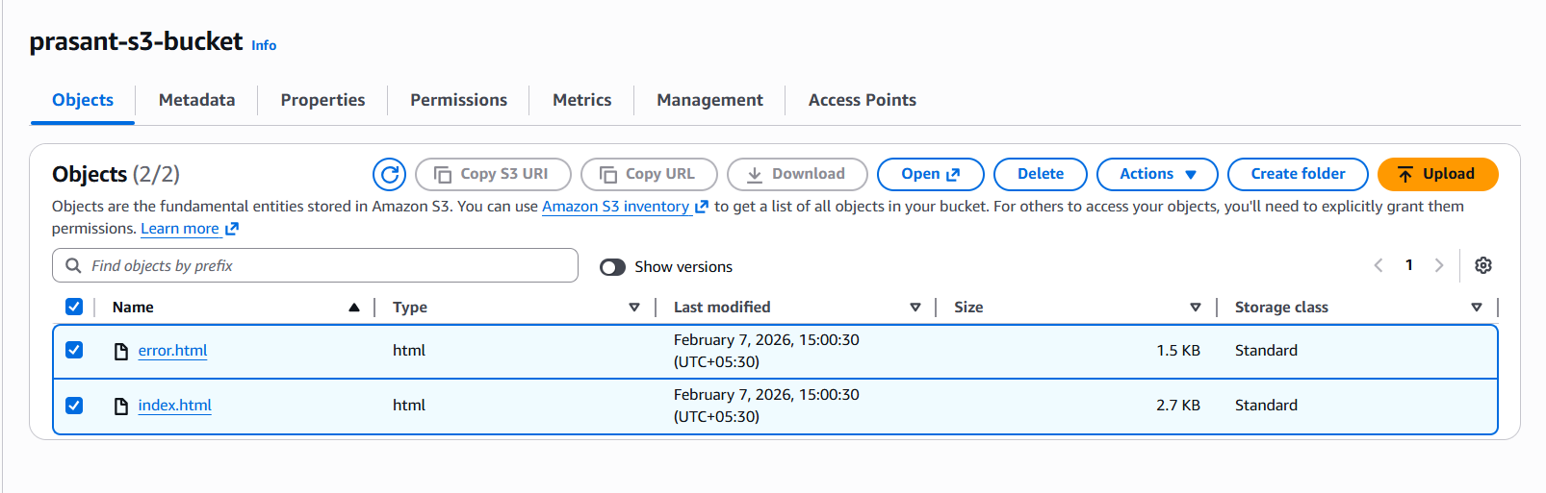
14.Go to nproperties
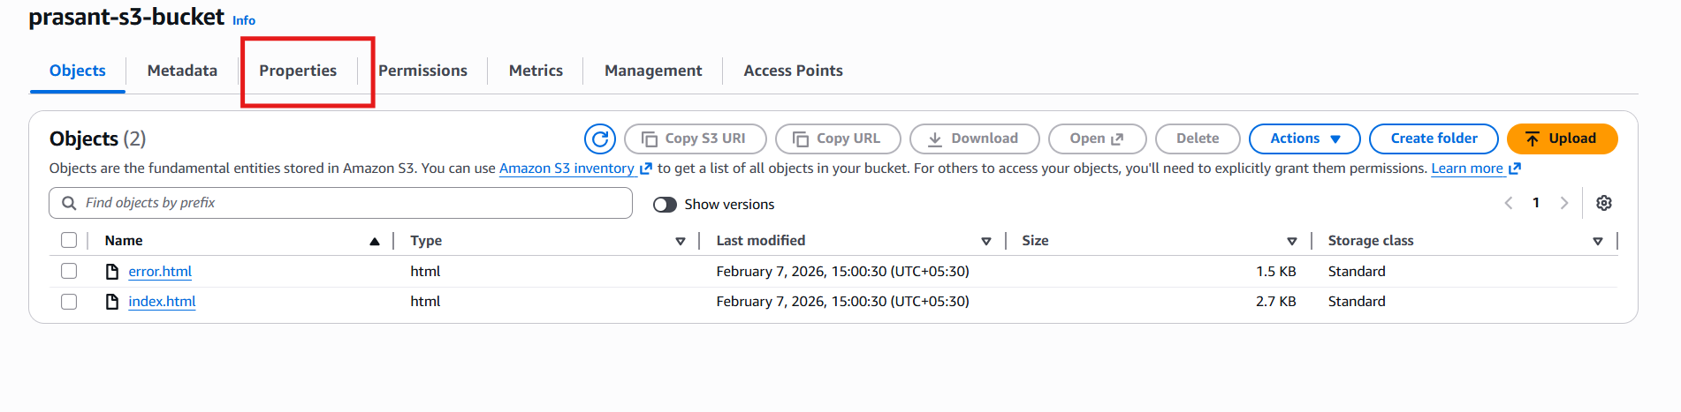
15.Do static website enable & enter file name
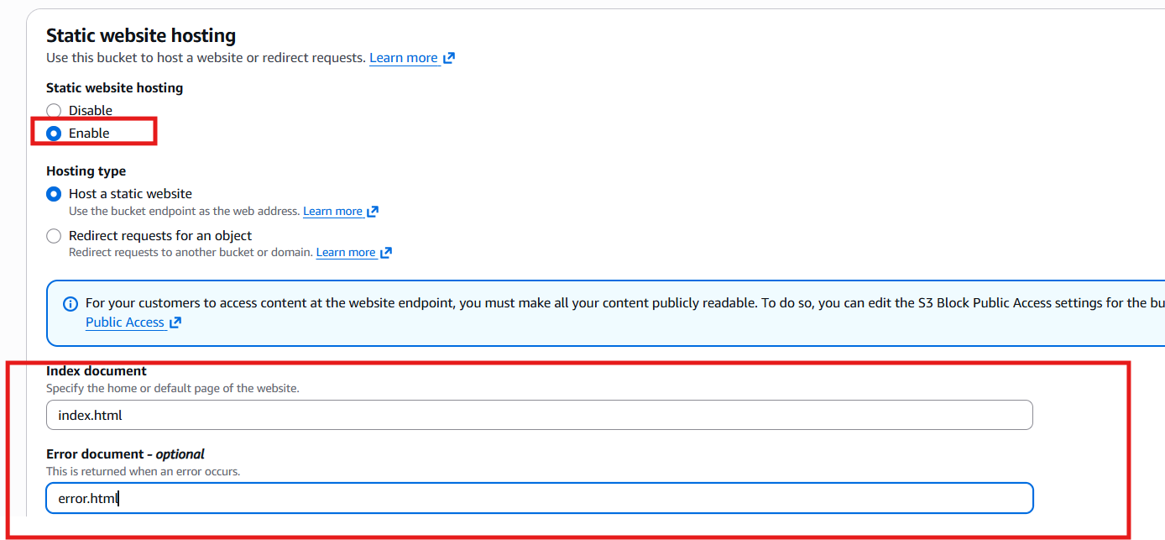

16.Do bucket ABAC enable & Click on save changes
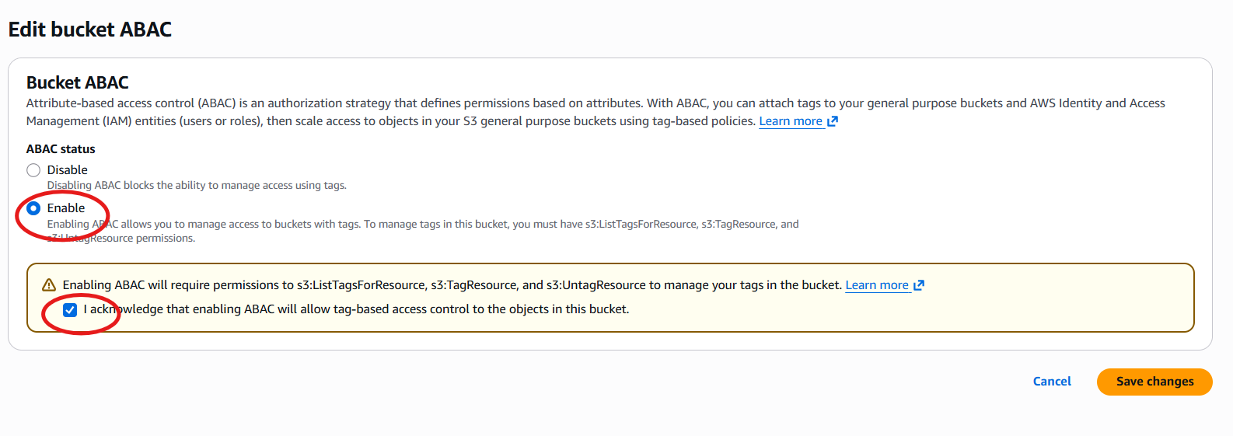
16.There will be a end point is created click om the link
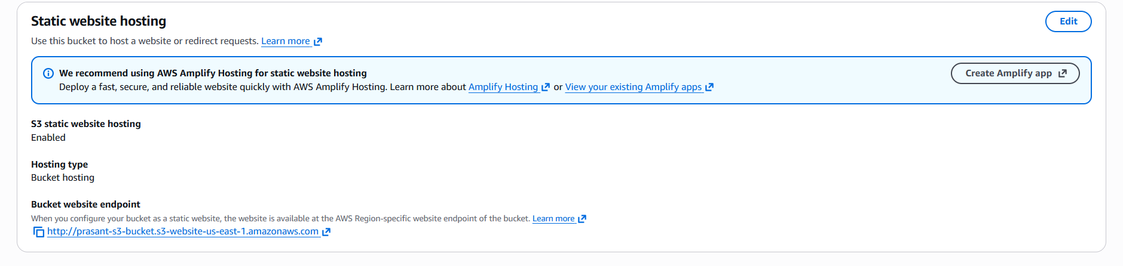
17.website is hosted
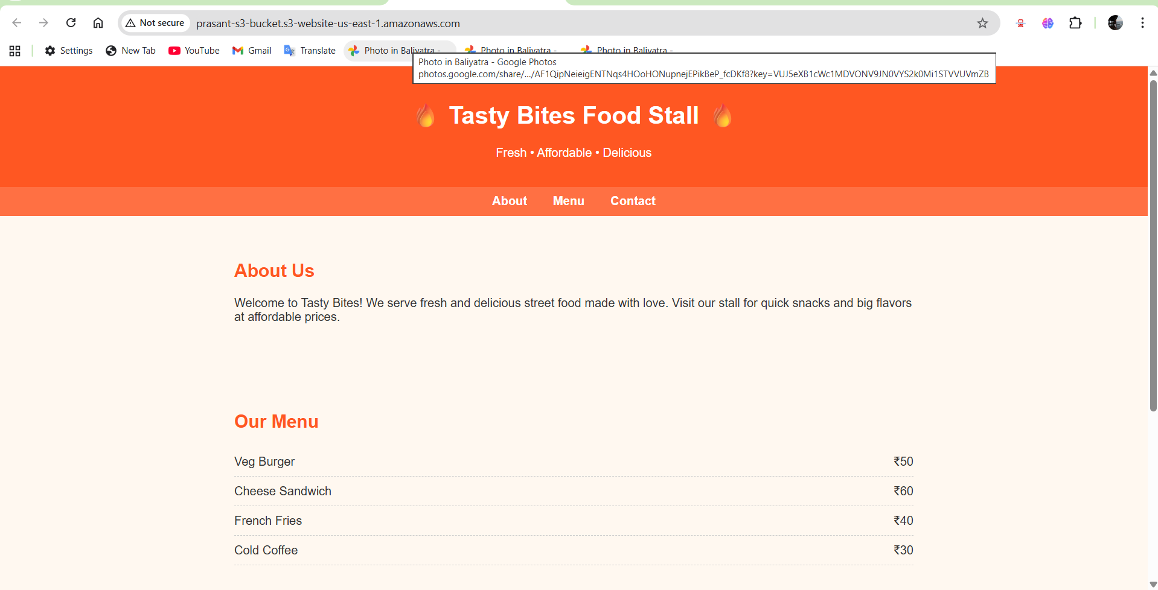

18.If we entered the url wrongly then the error .html will be executed
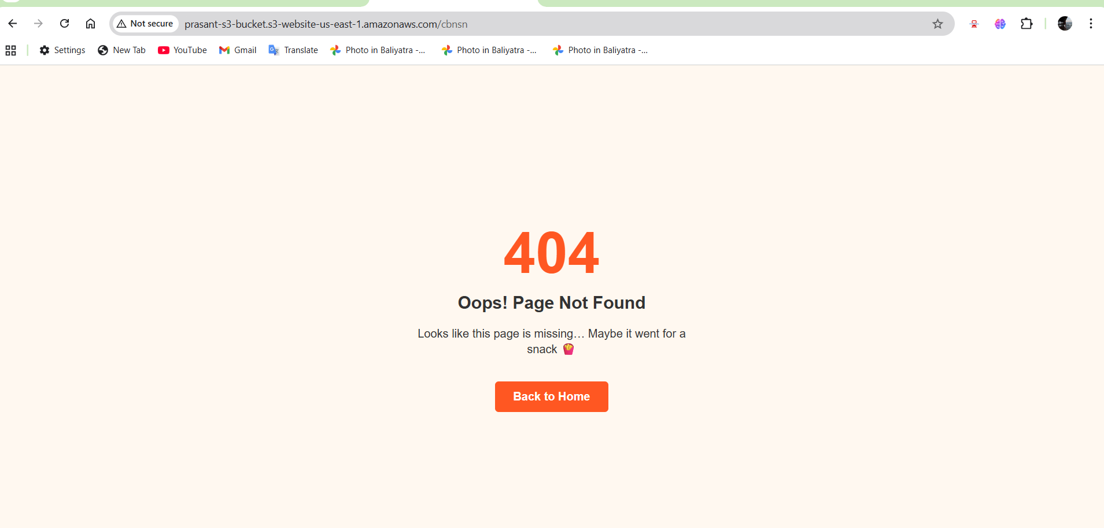

19.After click on Back to Home button we will go to our actual end point url

